Front Street Shelter
Cat Foster Handbook

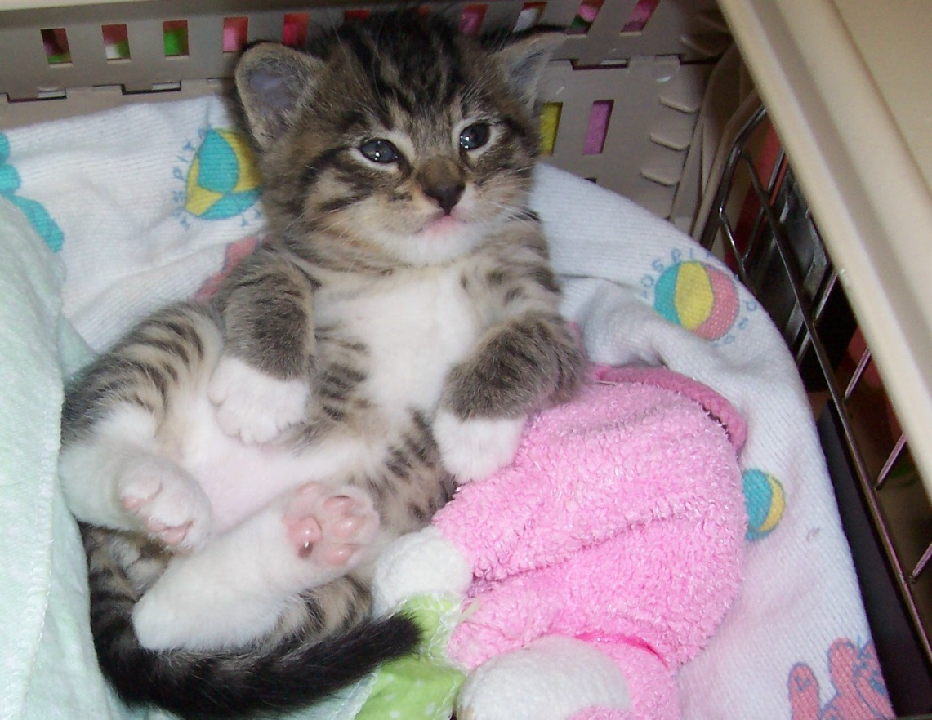
Widget - fostered in March 2008 and adopted in September 2008.

The Front Street Animal Shelter Thanks YOU!

Thank you for opening your home and your heart to a kitten or cat in need.

Whether you foster a kitten that needs some time to grow, or an adult cat who needs a little extra TLC, YOU make it possible for us to provide the very best care possible for all our residents at The Front Street Shelter. Fostering is messy, rewarding, stinky, adorable, and sometimes a heartbreaking job. We certainly couldn’t do it without valuable foster homes like yours!

From all our cats and kittens:

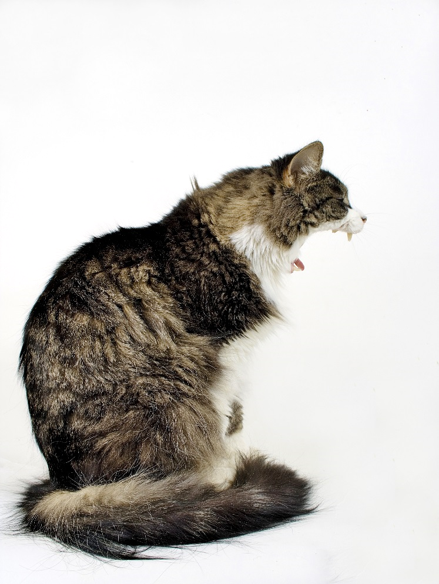
Thanks!

Greetings, Foster Parents!

Thank you for participating in The Front Street Shelter Cat Foster Care Program. We appreciate your willingness to open your heart and home to homeless mother cats and kittens. Your dedication allows our organization to rescue cats we would otherwise have to turn away due to limited space in our shelter.

The guiding mission of the Cat Foster Care Program is to give mother cats and kittens the individualized care and socialization they need to prepare them for adoption. Information gathered during the foster process helps us place cats and kittens in homes with families who can best meet their needs. Specific goals of the program include:

- Providing a safe, healthy, nurturing environment for mother cats to raise their kittens.
- Socializing shy or timid cats and kittens.
- Allowing mother cats to recover in a relaxing, uplifting environment.
- Giving orphaned kittens a leg up with the socializing and love a foster home can provide.

This manual outlines the responsibilities and expectations of The Front Street Shelter’s foster volunteers. This should serve as a resource throughout your foster care experience.

Before taking your assigned foster cats/kittens home, please:

- Review the overview of key responsibilities and policies.
- Read and sign the foster care agreement.
- Give these completed forms to the Foster Care Coordinator. If the Cat Foster Care Coordinator isn’t available, give the forms to the Supervisor on duty.
- Before you leave the shelter, schedule to come back for booster shots.

Overview of Key Responsibilities and Policies

To ensure a successful foster program, we ask that you follow our general policy guidelines to ensure that each foster home is responsibly providing a wonderful home for these kittens to grow up and explore the world in. To this effect, you will want to keep in mind the following;

- Keep cats/kittens inside at all times.

- Cats/kittens should be in a carrier at all times when leaving the house.

- Keep doors/windows closed at all times, unless covered with a screen that is securely in place.

- If a cat/kitten does manage to get outside, you must attempt to get the cat/kitten back inside immediately. If you delay, the cat/kitten may get frightened and run away, decreasing your chances of getting the kitty back inside. Do not chase the cat/kitten as this may make them run further away from your home. If you can’t get the kitty yourself within 1-2 hours, call your Foster Care Coordinator to determine a strategy to recapture the kitty. The Front Street Shelter has humane traps available if needed.

- When fostering it is important to keep them separated from your other animals. A seemingly fine cat can become ill due to stress from a move.

- Follow the instructions provided by the Foster Coordinator, Shelter Veterinarian or Shelter Supervisor.

**If your foster kitty requires emergency care YOU MUST GET PRIOR APPROVAL AND A REFERRAL from the Foster Coordinator or Supervisor

Contact List

Sundays through Tuesdays:
Patrick Schiller - Foster Care Coordinator - 916-764-6862
pschiller@cityofsacramento.org
If not available, contact:
Lori Rhoades - Supervisor - 916-215-4524
lrhoades@cityofsacramento.org

Wednesdays through Saturdays:
Sam Burgin - Foster Care Coordinator - 916-764-6862
sburgin@cityofsacramento.org
If not available, contact:
Suzi Springsteen - Supervisor - 916-215-4254
smarks@cityofsacramento.org

Joyce Thompson Pierce - Lead Foster Volunteer - 916-952-2023
Jtpierce9@yahoo.com
----
*Dr. Warner - Shelter Veterinarian – 916-730-7484
lwarner@cityofsacramento.org

*Please do NOT contact Dr. Warner unless you have been unable to locate any of the prior contacts on the list.
Kitty-Proofing Your Foster Home

Cat- proofing and especially kitten-proofing your home is much the same as child-proofing it! That means hiding or removing cords, removing small items that kittens can choke on, etc. Use the following tips as a guide to make your foster room and home safe for cats and kittens:

- Make sure the garbage, cleaning supplies, and medicine are secure.
- Get into the habit of checking your refrigerator, oven, washer, dryer, freezer, dishwasher, etc. before these doors get closed. Kitty may have leaped in. These horrible accidents happen more often than you would expect.
- Watch that hot irons or other hot or heavy objects a rambunctious kitty may knock down aren’t left out. Use non-toxic products whenever possible.
- Review the toxic houseplant list at www.aspca.org/pet-care/poison control/plants and remove all poisonous plants from your house.
- Keep all small items like rubber bands, paper clips, needles, thread, and fishhooks- anything kitty can swallow- out of reach.
- Never leave razors in the bathroom if this is where you are housing kitty.
- Keep plastic bags, which can cause suffocation, out of reach.
- Exposed electrical cords are a very real danger. Kitties will chew them and can be electrocuted. This can cause burns or death. Encase cords in flexible tubing (available at office supply stores) for just this purpose.
- The best way to prevent accidents is to house fosters away from hot items; water heaters, fireplaces, wood burning stoves can be hazardous.
- Remember cats/kittens are curious. Thus the saying, curious as a cat.

Housing
You must provide a clean, safe environment for your foster cats/kittens. The Front Street Shelter recommends that you use a spare bedroom or bathroom as your “foster” room.

If you are fostering a pregnant cat or a mom with kittens, keep the following tips in mind:
- Consider protecting your furniture and carpet with sheets or plastic table covers. Kittens can be messy, especially when they are learning to use the litter box! Make sure sheets/covers are securely tacked down so kittens don’t get under them.
- Until the age of 3-4 weeks, the mother cat will clean the kitten’s genitals to stimulate the bowels and bladder. As the kittens start showing interest in the litter box, provide them with an easily accessible box - a lower lipped box they can step over is essential.

Nesting Box
A clean, warm, dry, quiet, out of traffic site should be provided for mom to raise her babes. A nesting box is essential.
The box should be large enough for mom to lie comfortably away from her litter if she chooses, but small enough so the babies are easy for her to reach. The sides need to be high enough to prevent young from wandering, but low enough for mom to come and go.
Half a transport crate is perfect.
Line the box with newspaper, then with clean, dry, soft, non-shreddable, removable material.
Do not place babies in deep, loose bedding, (straw, hay, or shavings). These materials could obstruct breathing or be inhaled and cause respiratory infections.
Litter Box
Kittens should be introduced to the litter box when they start eating solids. They need a box with shallow sides. After they have eaten, place them in the box. They will learn to use the litter box very quickly. Sometimes they learn just by watching mom.
Observe how kittens watch all of mom’s actions; they find her fascinating and learn how to act like cats by observing her.

Scoop the box often…and NEVER use clumping litter with kittens - the dust can solidify in their lungs.

Supplies
The Front Street Shelter supplies:
- Wet food, dry food, and formula
- Litter (wood pellet-style)
- All medical care through our onsite veterinarian
- Medications prescribed by our veterinarian.

Expenses that you incur during your term as a foster care provider, whether for supplies or medical care, cannot be applied to an adoption fee later. These expenses, however, may be tax-deductible. Keep all receipts and ask for an “in-kind” donation form once your litter is adopted. For tax purposes, you should also track your mileage to and from the shelter and off sites.

Consult your tax preparer for details.

Getting Your Fosters
Please be on time when you are scheduled to pick up your foster/s, so that the shelter staff can use their time most effectively. If you are unable to keep this appointment or will be late, please call the Foster Care Coordinator to reschedule.
When you pick up the foster, you will also:
- Sign the foster agreement
- Get copies of the kennel card
- Food or litter, if needed
If you can bring your own carrier, it is appreciated.
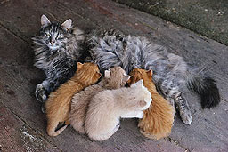
Neonatal (Nursing) Kittens
Handle newborns gently, but make sure to check them twice a day.
Are they nursing?
Hanging out with mom?
Crying a lot?
This could be an indication that they are cold or not getting enough milk. Make sure you count them each time you check on them.

Neonatal Signs of Trouble
If all kittens and mom seem well, your only obligation to them for the first week or so is watchful supervision. Mom will need kitten kibble and water at all times.
BUT…Contact the Foster Care Coordinator immediately if you observe the following in the mother cat:

- Acts lethargic, or as if she is in pain or continues to strain
- Ignores her kittens
- Continues bleeding from her vulva for more than two days
- Has painful, hard, or swollen mammary glands

The mother cat should groom each kitten after it eats, and lick their bottoms to stimulate elimination.
Contact Foster Care Coordinator if you observe any of the following in the kittens:
- Constant crying and failure to latch on.
- Refusal to nurse.
- Feels cold to touch.
- Withdrawing from the other kittens.
- Rejected or ignored by mother.

Socializing Your Foster Kittens

First and foremost, we ask that you treat your foster cat/kittens with the same love and care you give to your own companion animals. Daily attention (at least one full hour per day) from you and other family members or friends makes them more people-oriented, and more adoptable. This includes petting, playing, cuddling, trimming nails, and grooming.

By spending time with your fosters on a regular basis, you can learn more about their personality, which will help in matching them to the right family.

You should monitor for behavior problems, such as inappropriate urination or scratching furniture. If problems arise, contact your Foster Care Coordinator to
discuss behavior modification. The Front Street Shelter is not responsible for damages that might occur to yourself, others in your household, or your personal property as a result of feline behavior while in foster care.

If you have “cat friendly” dogs in your household, please consult with your Foster Care Coordinator about proper introductions. Felines who have been raised with dogs, adult cats, or children who enjoy or at least tolerate their company often have an advantage on adoption days!

Please don’t rough house with kittens or use your hands as toys, because it will encourage rough play with their “claws” when they grow up.

*Be careful! Children love to play with kittens, but they may not understand how to interact with them properly. Please keep in mind that children should not handle kittens under 3 weeks of age and you must not allow unsupervised handling of kittens by children of any age.
Feeding and Growth
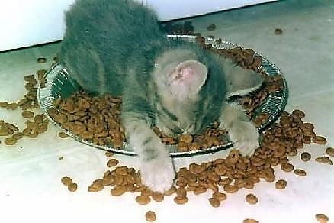
Fresh, clean water must be available to all animals at all times!

Mom with kittens:
A nursing mom should be fed a small amount of premium canned kitten food 3-4 times a day. Dry kitten food should be out for her at all times.
Kittens generally start showing interest in solids around 4-5 weeks of age. Each kitten can then be given 1 tablespoon of wet kitten food 3-4 times a day. Dry kitten food should be available 24/7.
Kittens without Mom:
Newborn to 4-week-old kittens are “bottle babies”. This requires more time and energy to foster. Continue reading for more bottle feeding info!
Materials Needed for Bottle Feeding:
- Cotton squares or cut up wash clothes
- Heating pad that does not shut off automatically
- Kitten bottle, formula, 3 ml. syringe
- Thermometer
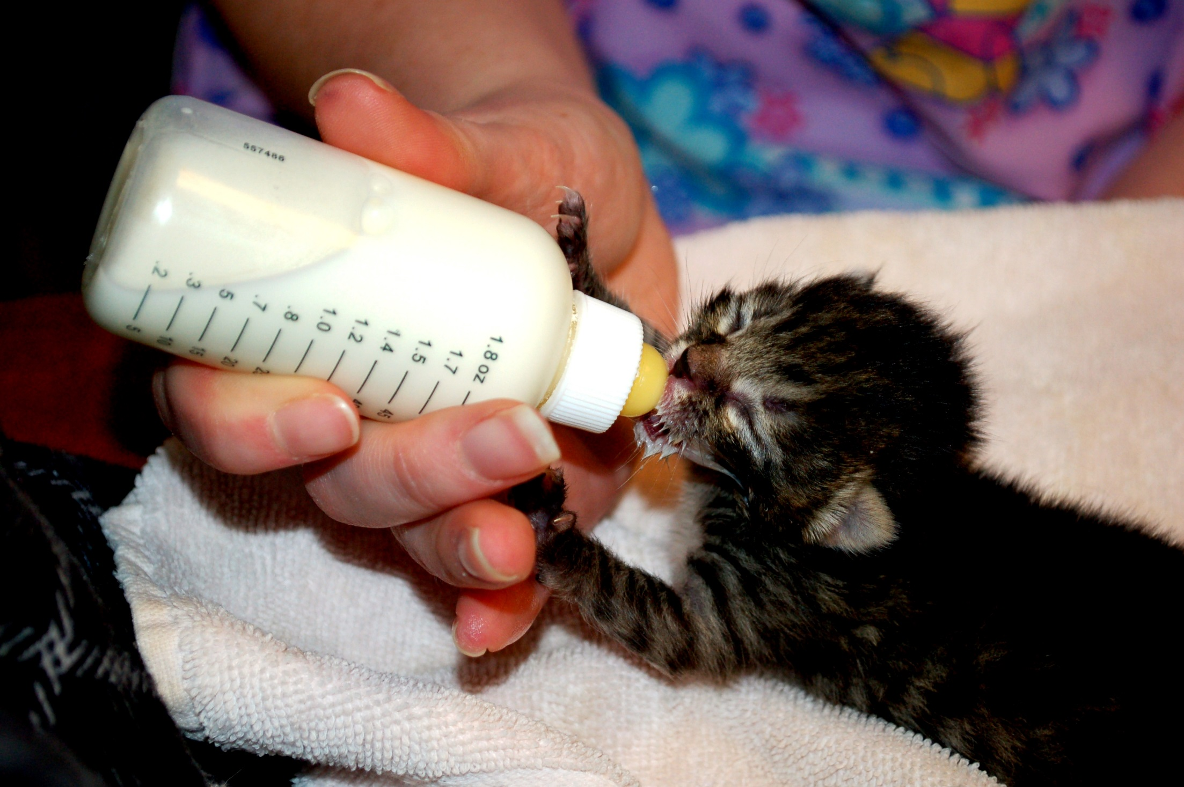
Use a kitten bottle to feed the kittens. The hole in the nipple should leak milk slowly from the bottle without pressure. The best way to create this hole is by heating a needle and poking it through the nipple in a turning motion. Be careful – it is easy to burn your fingers when heating the needle.
Never feed a chilled kitten, make sure they are warm prior to feeding. Body temperature should not be below 98 degrees F. Make sure formula is warm, not hot or cold, ideally 98 -100 degrees F.
Stimulating Kittens to Urinate or Defecate
Sometimes young orphans are unable to urinate or defecate on their own. Mom usually handles this by licking their bottoms after feeding (YUM!). Without mom there, you will need to rub their bottoms after feeding to mimic this. You will want to use square cotton balls or an old cut up washcloth (tongue not required).
They should urinate after every feeding and defecate twice a day on average.

Possible Potty Problems & Causes

Poop
White w/ cottage cheese consistency; possible overfeeding/ formula is too rich
Grayish & runny; possible bacteria problem
Greenish; possible overfeeding
Mustard brown, soft to firm; perfect
Yellow /whitish, clear/slimy; intestinal irritation
Yellow & stinky; possible coccidia
Contact Foster Coordinator immediately if poop is bloody or black!
Urine: Bright yellow to orange or brown; possible dehydration.
Contact Foster Coordinator immediately if pee is bloody or has a pinkish or reddish color!

Neonatal Health
Illnesses are usually acquired in utero, during the birthing process or in the post -weaning stage.
Fading Kitten Syndrome

A “fading” kitten is one that appears healthy at birth, but fails to survive beyond 12 weeks of age.
Checking Temperature
Normal is 100-102.5 degrees F.
You will need a rectal thermometer (made for human babies) to take cats temperature, preferably a digital one. Use petroleum jelly to lube the end of thermometer. If using a digital, place gently in cat’s rectum and leave it there until it beeps. If using a glass one, leave it in for 1 minute.
Be careful! The rectum can be damaged if inserted too far.
Contact Foster Care Coordinator immediately if cat/kittens temp is above 104*F.

Dietary Habits with Growth
- At 4 weeks, you can start introducing canned food mixed with formula to the consistency of gruel. This will be messy and bathing will be mandatory. After a few days, they will get the hang of it.
- 5-6 weeks: Four small meals of canned food per day. Size of a level tablespoonful. Always have dry food and water available 24/7.
- 6-8 weeks: Three meals a day (about an eighth of a can per kitten) and free feed dry food and water.
Overfeeding can cause digestive problems. Frequent small meals are preferred to large meals.
Kennel Cards
Contain all the information we collect on your fosters from their Animal ID # to vaccinations and medical treatment rendered. The Front Street Shelter does its best to track this, but there are up to 150 fosters at any given time. It is your responsibility as a foster care provider to help us keep your fosters on schedule for vaccinations and deworming. This is done every 3 weeks for fosters until 12-weeks old, then twice thereafter. You will want to schedule these appointments with your Foster Care Coordinator in advance.
Vaccination Reactions
Vaccine reactions can include, but are not limited to:
- Limping
- Not eating or drinking the normal amount for 1-2 days
- Lethargy.
- Pain at injection site
- Unwillingness to play
- Low-grade fever
If any of these symptoms persist beyond 48 hours after the injection, contact your Foster Care Coordinator.
Some cats or kittens have an immediate reaction to vaccines, including severe vomiting, diarrhea, facial swelling, and difficulty breathing. IMMEDIATE vet attention is required!
Kitten Development and Vaccine Schedule:
This is general information, courtesy of The Pet Foster Network, about the average stages of development. Please weigh your kittens regularly to keep an eye on development. Daily is best for the first 3 weeks or at any time if the kittens get sick, otherwise every 2-3 days is fine.
Newborn | Completely dependent on mother. Eyelids closed, ears folded forward – cannot see, or hear. Sense of smell is the first to develop completely and is the most developed sense at birth.
2-3 Days | Umbilical cord falls off.
One Week | Eyes begin to open – all kittens have blue eyes. Kittens huddle together for security and warmth.
10 Days | Ears unfold, hearing will develop. Can move along with belly on the ground, “paddling” limbs for movement.
Two Weeks | Being to play with littermates, learning how to socialize. Can stand and balance, but cannot walk easily. Teething begins. Eyes are fully open.
16-18 Days | Incisors (tiny front teeth) break through.
20-24 Days | Canine teeth break through.
Three Weeks | Mobile and eager to explore, making mock-aggressive rushes and stalking littermates. Cannot retract claws. Weigh the kittens regularly to keep an eye on development. Should be played with and handled at least 1 hour every day for good socialization.
24-28 Days | Molars begin to break through.
Four Weeks | Introduce solid food in 4 small meals per day. Begin litter box training. Will begin wrestling with littermates. Will receive first deworming (Strongid). Ask your mentor for help with dosing and administration.
Five Weeks | Learning to hunt by pouncing on toys and each other.
Six Weeks | Adult eye color begins to appear. First vaccination for kittens. Kittens are vaccinated against common agents that cause upper respiratory infection and feline distemper (FVRCP). Receive second deworming.
Eight Weeks and Older | Mom and kittens need to be brought to the shelter for their scheduled surgery appointment. The exam will include: FeLV and FIV testing if not previously done, deworming if needed, spay or neuter (if weight is at least 2.25 pounds and kitten is healthy), microchip, treatment for fleas and ear mites as directed by the veterinarian, and possibly another vaccine. It is expected that you will notify the Foster Coordinator as soon as your kittens reach 2 pounds so they can be scheduled for surgery as quickly as possible. Second vaccination occurs 21 days after the first.

Vaccines and Worming Treatments

Vaccines:
FVRCP is the vaccine for Feline Viral Rhinotracheitis, Calici Virus, and Panleukopenia (URI and Distemper)

- FVRCP is given at 6 weeks of age or older depending on when they went through intake.

- 2nd FVRCP is given 21 days after the first FVRCP. No later than 31 days after or you will need to restart the series.

- 3rd FVRCP is given 21 days after the second FVRCP. No later than 31 days after or you will need to restart the series.

- 4th FVRCP is given 21 days after the third FVRCP. No later than 31 days after or you will need to restart the series. This vaccine may not be given if the kitten was vaccinated after its 16 week date with the 3rd FVRCP.

Worming:

Pyrantel is for Round Worms. You might see these and they will look like spaghetti.

- Pyrantel is given at 4 weeks of age or older depending on when they went through intake.

- 2nd Pyrantel is given 14 days after the first dose. This series is repeated every 2 weeks until the kittens have returned for adoption. If you are more than 21 days late you will need to restart the dosing series.

Cestex is for Tape Worms. You will see rice-looking segments in their stool.

Health Concerns
Common medical issues you may encounter. This is not meant to be extensive, just to give you an idea of common ailments.
If your foster displays any of these symptoms, call your Foster Care Coordinator immediately.

- Sneezing and/or congestion with green or yellow discharge from nose or eyes.
- Coughing, wheezing, or heavy breathing.
- Diarrhea or vomiting- This can be life threatening to kittens!
- Straining to urinate or defecate - This can be life threatening, especially in males!
- Bleeding from any part of the body.
- Lethargy.
- Fever.
- Paralysis.
- Extreme change in attitude or behavior.
- Not eating or drinking.
- Temperature too low (below 98*) or too high (above 104*).

Please take the animal’s temperature
before calling. Be prepared to tell the
Foster Care Coordinator
specific details about the situation.

Grooming
Most adult cats are good at cleaning and grooming themselves. However, it is still necessary to groom them regularly. This action accustoms a cat/kitten to being handled and allows you to check for any health problems. Regular grooming can make it easier for the vet to examine the cat/kitten.
Longhaired cats will require much more frequent grooming. Regular grooming will prevent snarls and tangles on the abdomen and around the inner thighs.
Rest the cat in your lap and gently groom it with a comb or brush, depending on the coat. Paws, toes, ears, and mouth should be checked as part of the grooming. Keep sessions short (about 5 minutes). If a cat/kitten is less than thrilled with this routine, you may need to hold them by the scruff of their neck. This will prevent its leaving or offering too much resistance. Offer treats to reward them for tolerating grooming.
Ears
Check foster’s ears at least once a month, orphans more often. Carefully clean wax deposits with a cloth wrapped finger or a cotton swab dipped in baby oil.
Be alert to inflammation or foul odor. Observe if the cat/kitten shakes its head repeatedly, rubs it against the floor, tilts it to one side or scratches at its ears.
Eyes
Keep eyes clear of any discharge.
Trimming Nails
Nails grow continuously. Before trimming nails, get it accustomed to having its paws handled. Gradually increase pressure on the paw so that petting becomes squeezing, as you will need to extend the claw.
You should be able to see the “pink” or “quick”, which is a small blood vessel. You DO NOT want to cut into the pink portion, as it will bleed and be painful.
If you cut just the sharp tip of the claw, it will dull the nail and prevent damage from scratching.
Nails can be trimmed weekly.

Incident Reports
California State Law requires any animal that bites and breaks the skin be placed on a 10 day quarantine to observe for rabies.

Handling a Bite Incident
- Clean and flush wound immediately with soap and water.

- Report the incident to a staff member. State which animal was involved and the circumstances of the bite.

- See your doctor. The doctor may recommend a tetanus shot and antibiotics.

During this time the cat/kitten may be quarantined in your home, unless you are uncomfortable with this arrangement. The cat/kitten may be returned to the shelter and placed in quarantine.
If a bite is not reported, it creates a hazard for others handling the animal and we may release a rabid animal into the community.

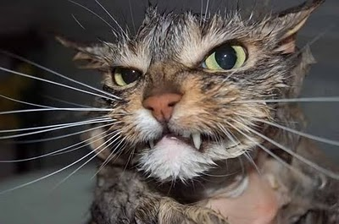

What’s In a Name?
Giving your foster a cute or unusual name can help them get attention – and get adopted. Common names, such as Fluffy, Boots, Angel or Cocoa, don’t help!
Use a famous name, add a last name or even use a theme (like movie stars, city names, etc.) if you have multiple fosters.
Recent litters in foster have been named after The Bee Gees, presidents and their wives, Klingons and the characters from Friends. It makes people laugh and helps get a conversation started with potential adopters.
Names need to be friendly, non-offensive, and not difficult to pronounce or spell. Names that may have negative associations – such as Freddy Krueger, Killer or Satan – should not be used.
Marketing Your Foster
Choosing a memorable name and doing a personality profile will help introduce them to potential adopters. These can make your foster stand out in a room full of cats/kittens. After having a foster in your home, you have a great deal more info to share with an adopter. Help your foster stand out in the crowd.
The Front Street Shelter also has a Petfinder account. If you are interested in posting your foster, write up a resume on its personality and behavior. This info, coupled with great photos can be forwarded to the lead foster volunteer to be posted on Petfinder.

Showing Fosters at Offsite Adoption Events
Adult cats and kittens that weigh 2 pounds or more can go to off-site adoption events.
An assigned volunteer will be in charge of each off-site. Emails will be sent once a week; you will need to reserve a space. Please do not just show up. Be sure to follow the directions given by the Lead Volunteer.
Plan to be present during the off sites. Your fosters will respond better to the public if you are there to support them in this endeavor.
When you bring your fosters to be adopted, it is important to fill out the “I’ve been in a foster home” form; if you have any photos to attach, please do.

Being an Ambassador for the Front Street Shelter:
As a Foster Volunteer, you are an ambassador for the shelter. You are the face of the shelter to those that you meet and talk to. Please remember to always be a good ambassador. Read up on the shelter and keep current with what is happening. Follow us on Facebook. Read your volunteer newsletter. Become familiar with our website (www.sacpetsearch.com) and the different programs we offer, so that you can properly represent the shelter to those that ask. CUSTOMER SERVICE IS KING! It is very important that any potential adopter is treated with respect and dignity, and has a great experience with our shelter.

What to do when you find an adopter:
The primary purpose of our foster program is to help these cats and kittens find a new home! This means that, ideally, the cats and kittens never come back to the shelter – they go from your loving foster home to their new fur-ever home.
That means that you are in the perfect position to help find potential adopters. Be sure to market your cats and kittens on your Facebook page, to your friends, family, co-workers, and neighbors. Here are some things to keep in mind about adoptions:
• If you have been trained to do adoption counseling, you may complete the meet & greet and adoption counseling on your own.
• If you have not taken the adoption counseling training, please do so before you attempt to complete an adoption. It is best to arrange a meeting with shelter staff or with the lead foster volunteer in order to complete the adoption, if you have not yet been trained.
• Kittens under two months and two pounds may not yet be adopted. A potential adopter may express interest and intent, but they must wait until the kitten is two months and two pounds before completing the adoption.
• All adoptions must be completed at the shelter. Adopters must come to the shelter and complete the paper work here. Fosters should never collect the adoption fee or send a cat or kitten directly to a new home.
• All cats and kittens must be spayed or neutered prior to going to their new home.
A “Free” Kitty is Never Free!
A “Free” Kitty: | A Kitty From Front Street:
–Average Costs –  - New Patient Vet Exam - $42  - Spay/Neuter - $152/$105  - FeLV and FIV Testing - $57  - Microchip (and Registration) - $50  - FVRCP and FeLV Vaccinations - $41  - Treatment for Parasites (Fleas, Worms, Etc.) - $38  - Collar - $6 | – Included in the Adoption Fee –  - Veterinary Exam  - All Medical Care Prior to Adoption  - Spay/Neuter  - Testing for FeLV and FIV  - Microchip  - FVRCP Vaccination  - Rabies Vaccination  - Treatment for Parasites (Fleas, Worms, Etc.)  - Collar/Nametag  - Samples of Food  - 30 day Return Policy
TOTAL  $386 or more | TOTAL  $65

“I‘ve been in a Foster Home” Form

This is what my foster family has to say about me!

Animal’s name: ____________________________________________________

Type of food fed in foster home: ______________________________________

Feeding schedule/amount of food: _____________________________________

Favorite toys: _____________________________________________________

Experience with dogs? ______________________________________________

Experience with cats? _______________________________________________

Experience with children? ____________________________________________

Litter box Trained? __________________________________________________

Crate trained (canines)? _____________________________________________

Other useful information: ____________________________________________

Foster Volunteer’s name / contact info (optional): ________________________

Professional Pictures

By appointment only through our Foster Care Coordinator, we have a professional photographer at the shelter volunteering her time on Tuesdays. Again by appointment only! Good photos can help get your babies adopted.

Your foster must be spayed/neutered before going to their new adoptive home. If they are adopted but have not been fixed yet:
- Make an appointment through your Foster Care Coordinator. Please allow up to 2 weeks notice during our busiest season. When scheduling use Animal ID# or name of kitten if it is on the kennel card .If you need to cancel contact the shelter immediately!
- If kitten is already adopted we will give you a date to bring kitten in for surgery, that afternoon they will be picked up by their new family.
- No food after 6 am. Do not feed breakfast. Water is fine. The anesthesia can make them sick and we don’t want them vomiting. They can choke and this can be life threatening.

Cleaning After Your Fosters Are Adopted
The joy of fostering is that YOU have changed their lives and made it possible for them to find loving, permanent homes. Well done!
It is important to clean up after fosters leave, whether or not new fosters will be coming in.
Use soap and hot water on all washable surfaces, and bleach is a good idea as well. Let all surfaces air dry. If carpeted areas are in need, consider steam cleaning.

Foster Care Agreement

Please Read and Sign

- I understand the goals and mission of Front Street Shelter and, as a Front Street Shelter volunteer, agree to work toward these goals and to represent this mission within the community on behalf of the organization. My commitment includes abiding by The Front Street Shelter foster care guidelines, as outlined in Front Street Shelter Foster Program Manual, which I have received. This includes, but is not limited to:

  - A commitment to keep Front Street Shelter’s foster cat(s)/kitten(s) indoors and not expose them to other cats that have access to outdoors.
  - A commitment to follow Front Street Shelter’s instructions with regard to medical care.
  - Moms and kittens must be housed separately in their own room.

- I understand that only Front Street Shelter’s Foster Coordinator, Front Street Vet and the Supervisor have the authority to make exceptions/changes to program guidelines.

- I understand that Front Street Shelter is the sole guardian of cats/kittens in foster care and that fostered cats/kittens must be returned to Front Street upon Front Street Shelter’s request. I understand that Front Street Shelter has the right to terminate this foster care agreement and relationship at will.

- I understand that if I, as a foster volunteer, want to adopt any of my foster cat(s)/kitten(s), I must go through the standard Front Street Shelter’s adoption process. I also understand that I cannot send any of my foster cat(s)/kitten(s) to an adoptive or potential adoptive home until the cat(s)/kitten(s) has been altered, the adoption process has been completed by a trained Adoption Counselor and the Foster Coordinator has been informed. Furthermore, I must have permission from the Foster Coordinator before sending my foster cat(s)/kitten(s) to another approved Front Street foster home. I also understand that expenses for food, litter, treats, scratch posts, etc. cannot be applied toward adoption fees should I adopt a cat(s)/kitten(s).

- I understand that foster cat(s)/kitten(s) need to be taken to Front Street Shelter’s on-site Veterinary Hospital for any medical care and can be reached at916-764-6862. The Front Street Shelter funds all medical care, and in the event of a medical emergency after hours or on the weekend approval is needed by the Foster Coordinator, Foster Mentor, Front Street Shelter’s on-site Vet or Vet-Tech, and only if the medical care is provided at a Front Street Shelter approved veterinary clinic or hospital. I understand that if I choose to take my foster cat(s)/kitten(s) to a non-approved veterinary clinic, or if I take my foster cat(s)/kitten(s) to an emergency veterinary hospital without prior approval, The Front Street Shelter will not reimburse me for the expenses incurred.

- Further, I agree that as a Foster Care Provider that Front Street Shelter shall be held harmless from any and all claims, liability, judgments, losses, damages, expenses, or cost of any kind arising out of any injury related to The Front Street Shelter Foster Care Program.

- I understand that I will be asked to bring my kittens who are 6 weeks or older to one of our offsite adoption centers once a month during their regular adoption hours. This will only apply while I am actively fostering and have healthy kittens that meet the requirements to be eligible for adoption at our offsite adoption centers.

- I understand that if I need to leave town during my foster period that I will need to give a two-week notice when possible to the Foster Coordinator for my kittens to be permanently rehomed to another Front Street Shelter’s foster home.

________ ______ Printed Name of Foster Parent Signature Date

Foster Coordinator Date

Name(s) of foster cat(s)/kitten(s) sent to foster on this date:

Being a Foster Volunteer – a word from Janice Wagaman, Volunteer Coordinator:

As a Foster Volunteer for the Front Street Animal Shelter, you are an important part of our volunteer team. Even if you never come to the shelter to do anything other than pick up your foster babies, you are still part of Team Front Street! As a valued volunteer, we ask that you be part of our volunteer system. We will need you to complete an online volunteer profile and log your hours. We also ask that you attend a regular volunteer orientation and shelter basics class, if you have not already done so, so that you are familiar with the volunteer program and the shelter itself.
Our volunteer program is now online! We ask that you regularly log your foster hours on your volunteer profile. You are such an important part of our team – your hard work should be counted and celebrated. If you have any questions about the volunteer program or the online volunteer system, please contact our Volunteer Coordinator, Janice Wagaman, directly at 916-808-8166 or jwagaman@cityofsacramento.org.

Online Volunteer System
The Front Street Animal Shelter uses the “MyVolunteerPage” program. As an FSAS volunteer, you are expected to use the scheduling, training, and hours log appropriately.
To register as a volunteer:
• Go to our website www.sacpetsearch.com
• Click on the Volunteer tab on the left
• Click on Become A Volunteer
• Click on Sign Up
• Create a user name & password
• Complete your volunteer profile
• Be sure to send an email to jwagaman@cityofsacramento.org to let her know you are a foster volunteer so that your volunteer profile will be activated.
To access the volunteer system:
• Go to our website www.sacpetsearch.com
• Click on the Volunteer tab on the left
• Click on “Registered Volunteers Sign In Here”
• Click on Log In and use the username and password you created when you completed your online application. If you forget your username or password, please email me at jwagaman@cityofsacramento.org and I will send you the information. DO NOT create an additional profile!
To sign up for shifts/training opportunities:
• Log in to your volunteer profile
• Click on the Sign Up tab
• Click on the activity or training opportunity you are interested in
• Check the box next to the date you would like to attend
• Click SAVE!
• Only opportunities that you are qualified to participate in will be available for you to sign up
• We ask that you sign up for the shifts that you want to work so we will know who is coming in when
To update your profile:
• Log in to your volunteer profile.
• Click on the My Profile tab.
• Click on the Qualifications tab.
• Update the trainings you have taken
• Update other information as needed – basic info, additional info, interests, availability, and goals
To log your hours:
• Log in to your volunteer profile
• Click on the Hours Log tab
• Select the appropriate activity
• Select the appropriate date
• Enter the hours you worked on that activity
• Enter your accomplishments as indicated
• Please use this formula to determine the number of hours to log for foster care:
1-2 Cats/Kittens: One hour per day per cat/kitten
3+ Cats/Kittens: 3 hours per day total
Bottle babies: 4 hours per day total
To access the “MyVolunteerPage” system on your smart phone, go to MyVolunteerPage.mobi.

